**CP Club 365 Days Challenge**

**Programming language – C++**

**Problem Statement**

<https://leetcode.com/problems/binary-tree-zigzag-level-order-traversal/>

Git :- <https://github.com/Vedantbharad2603/CP_club_365_Days>

**Your Code**:

// 0x125Day of 0x365Days challenge

// VEDANT BHARAD

// 17-2-2023

class Solution {

public:

    vector<vector<int>> zigzagLevelOrder(TreeNode* root) {

        if (root == NULL) {

        return vector<vector<int> > ();

    }

    vector<vector<int>> toReturn;

    queue<TreeNode*> tempQueue;

    tempQueue.push(root);

    bool ltr = true;

    while ( !tempQueue.empty()) {

        int size = tempQueue.size();

        vector<int> row(size);

        for (int loop = 0; loop < size; loop++) {

            TreeNode* node = tempQueue.front();

            tempQueue.pop();

            int index = (ltr) ? loop : (size - 1 - loop);

            row[index] = node->val;

            if (node->left) {

                tempQueue.push(node->left);

            }

            if (node->right) {

                tempQueue.push(node->right);

            }

        }

        ltr = !ltr;

        toReturn.push_back(row);

    }

    return toReturn;

    }

};

**Output (Screen Shot)**:

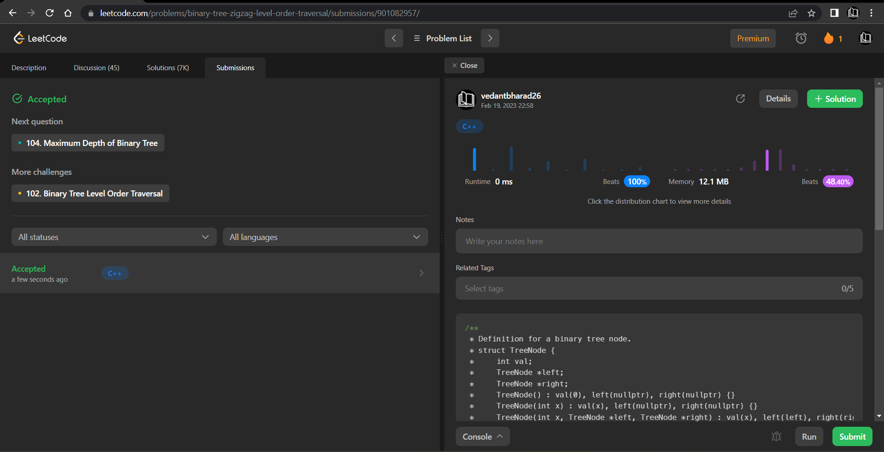

**Understanding about problem:**

* In this task I need to return one vector in which there will be zigzag level order traversal of given binary tree.

Note: If you can't understand the problem, feel free to contact us and we'll help you. Please don't copy and paste from anywhere.

ALL THE BEST

Team CP Club